ATF workshop : (any trader can fly )

Strategy :

Timeframe --- 5 min

Chart – nifty or bank nifty future

Candle stick pattern – 3 candle pattern

King candle and queen candle strategy :

* King candle high break = buy
* Queen candle low break = sell

King candle :

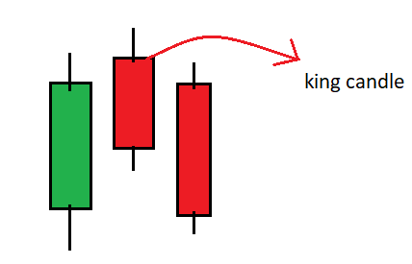

King candle conditions :

* The middle candle should have the highest high among the three candle
* The adx should give buy signal or green line should be above red at the time of king candle
* Rsi should be above 60

Condition for entry and exit :

When the high of the king candle breaks then that will be the entry

Stop loss : Low of the king candle will be stop loss

Target : target should be end of the day (trainer said )

But let’s make it 1:2 and then trail

Queen candle :

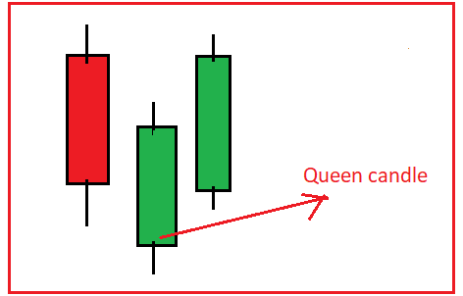

Queen candle conditions :

* The middle candle should have the lowest low among the three candle
* The adx should give sell signal or red line should be above green at the time of queen candle
* Rsi should be below 40

Condition for entry and exit :

When the low of the queen candle breaks then that will be the entry

Stop loss : high of the queen candle will be stop loss

Target : target should be end of the day (trainer said )

But let’s make it 1:2 and then trail

Notes :

* candle’s color doesn’t matter
* only the first king candle and queen candle of the day should be considered